POCKET CRIBBAGE GUIDE

Rules • Scoring • Pegging • Strategy

QUICK START
The Aim
Be the first player to score 121 points by:
• Pegging (the play phase)
• Counting your hands
• Lastly, the dealer counts their crib
Leapfrog your pegs after every point scored

CARD VALUES
Ace = 1 (always low)
2–10 = Face Value
J Q K = 10

1.DEALING (cut for first dealer)
Two Players
• Cut & deal 6 cards each
• Players discard 2 cards into spare dealers hand (crib)

Three Players
• Cut & deal 5 cards each
• All players discard 1 card into dealers crib
• One extra card is dealt face down into the crib

Four Players
• Cut & deal 5 cards each
• Everyone discards 1 card into dealers crib

The cut & starter card (or ‘turn-up’)
Player to the left of the dealer cuts pack and dealer turns-up starter card. This counts in your hand.
If it’s a Jack, dealer scores 2 points

2.PEGGING (or play phase)
Players take turns laying a card & stating running total
Running total cannot exceed 31
Score immediately for:
15 running total = 2 points
31 running total = 2 points
Pair = 2
Three of a kind = 6, Four of a kind = 12
Run of 3 = 3 (consecutive, in any order)
Run of 4 = 4 (consecutive, in any order)
Run of 5 = 5 (consecutive, in any order), etc..
Last card = 1 point

NOTE: Flushes don’t score & starter card not in play
When nobody can play without going over 31, say Go
Count returns to zero, played cards are turned face-down and play resumes to left of dealer until all cards are played

3.COUNTING YOUR HAND
Starting to left of dealer, count your four cards including the starter (turn-up card). State the running total
Score: Fifteens
Every combination making 15 = 2 points

Pairs
Pair = 2, three of a kind = 6, four of a kind = 12

Runs
Three or more consecutive cards
Runs don't need to be the same suit
Duplicate cards can create multiple runs
e.g. 6,6,7,7,8 scores 12 in runs

Flush
Four cards same suit = 4
Including starter = 5
The crib only scores a flush if all five cards match

His Nob
A Jack in your hand matching the starter card suit
= 1 point (easily missed)

THE CRIB
Finally, the dealer counts the crib the same as any hand including starter card
Cards are collected by player to left of last dealer, shuffled, cut and dealt for next round (back to 1)

THE END
As soon as a player gets to 121 the game is finished, we have a winner. Unplayed cards are returned to the pack and congratulations offered to the winner.

BEGINNER STRATEGY
Keep good hands
Don't break up:
• Pairs
• Runs
• Fifteens

Think about the crib
Your crib - throw useful cards (e.g. K, 5)
Opponent's crib - throw awkward cards. (e.g. K, A)
Avoid:
• 5s
• Pairs
• Cards making 15

Fives are gold
Never throw a 5 into your opponent's crib unless absolutely necessary

Peg carefully
Strategy is key, don't simply play your lowest card
Watch for:
15 total
31 total
Pairs
Runs
Sometimes preventing your opponent scoring is the best play

Play the board strategically
You're racing to 121
When you’re well ahead, one safe point is worth more than chasing four risky ones
When you’re behind, maybe time to take more chances



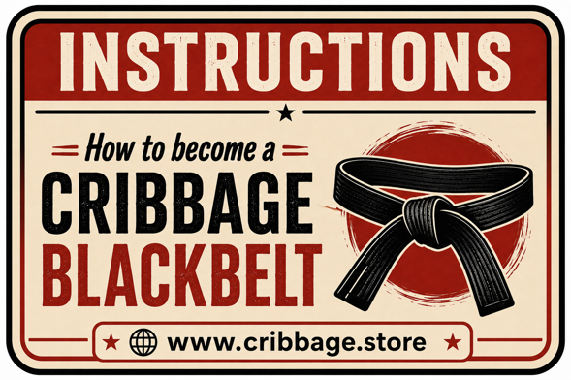

www.cribbage.store

